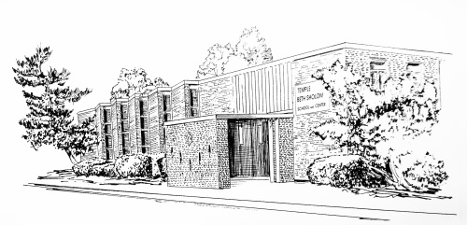
Date:_______________
Temple Beth Sholom Membership Application

Please fill out the following information.

Adults in Household:

Name: _________________________________________________________DOB: ______________________

Name: _________________________________________________________DOB: ______________________

Primary Address: __________________________________________________________________________

___________________________________________________________________________________________

Secondary Address: ________________________________________________________________________

___________________________________________________________________________________________

Home phone: ______________________________Cell phone: ______________________________________

Alternate phone: __________________________ Alternate Cell Phone: ____________________________

E-mail(s): _________________________________________________________________________________

Number of Children in Household: _____________________

Name: ________________________________________________________ Age: _______________________

Name: ________________________________________________________ Age: _______________________

Name: ________________________________________________________ Age: _______________________

Previous synagogue affiliation:

Name: ____________________________________________________________________________________

Address: _________________________________________________________________________________

Application for:

____ Family Membership ($1050 annual dues) ________________________________________________

____ Single Membership ($600 annual dues) ________________________________________________

Is anyone in your family a Cohen or a Levi? If “YES” please specify: __________________________________

Please return to 600 Nantasket Avenue Hull, MA 02045
For further information or questions, please call (781) 925-0091
Or email templebethhull@comcast.net

